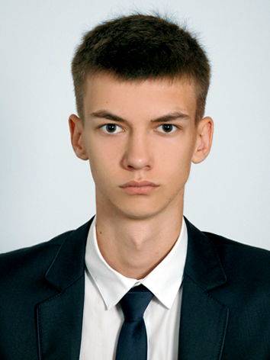

Contact information

|  |  |  |  |  |
| --- | --- | --- | --- | --- |
| Phone: +380680582119  Email: palamarchuk.vol@gmail.com  Skype: vovan28131 | | | Volodymyr Palamarchuk | |
|  | | Intern | | |
|  | | | | |
| Summary of Qualifications | Bachelor in electrical engineering  National Technical University of Ukraine "Igor Sikorsky Kyiv Polytechnic Institute"  FreeCodeCamp | | | |
|  | | | | |
| Skills | HTML, CSS, JS, Git, Linux, Windows, TCP/IP. | | |  |
|  |  | | | |
| Experience / IT related educational practice | He studied Java script. At this point, he began to study Devops engineering through online resources. | | | |
|  |  | | | |
|  |  | | | |
|  |  | | | |
|  |  | | | |
| Languages | English - Intermediate low | | | |
| Ukrainian – native | | | |
| Russian – second languages | | | |
|  |  | | | |
| Education | Bachelor in electrical engineering **2015-2019** | | | |
|  | | | |
|

|  |  |  |
| --- | --- | --- |
| Additional education (courses, trainings) | FreeCodeCamp | |
|  | | |
| Hobbies | Basketball, music, new technology, ski, learn something new |  |